CS 3350 Assignment 5 Due: Sunday, Nov.17, 11:59 p.m.
The goal of this assignment is to practice with the operations of trees.
You are given an assignment5.cpp file. Create an empty project and include the given cpp file.

Your Tasks:
- Complete the function of int height(Node* root) that returns the height of a tree.
- Complete the function of int size(Node* root) that returns the total number of nodes in the tree.
- Complete the bool isComplete(Node* root) that returns a Boolean value indicating whether the tree is a complete tree or not.
- Complete the void convert_BST(Node* root) that converts the given binary tree to a binary search tree, but maintain its original structure: The position of nodes in the tree does not change, but the keys in the nodes are changed to make it a binary search tree.

Note:
- You are not allowed to change anything inside the main () function.
- You can include any C++ library. You can also write any helper function to help you complete the four tasks.

Sample output:
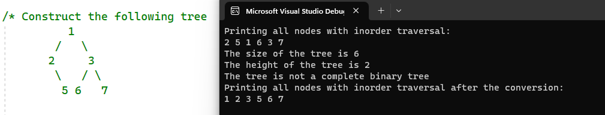

What to submit
- A single assignment5.cpp file

Grading Rubric
_______ (4) proper documentation/comments where appropriate.
______ (2) implementation of int height(Node* root)
_______ (2) implementation of int size(Node* root)
_______ (6) implementation of bool isComplete(Node* root)
_______ (6) implementation of void convert_BST(Node* root)

